Special Educational Needs and Disabilities (SEND) Information Report

St Mary’s Church of England (VA) Primary School



**Inclusion Team**

**SEND Governor:**

Father Dane Batley-Gladden

**SENCo:**

Mrs Caroline Hawkins

Contact No. 01322 665212

[chawkins@st-marys-swanley.kent.sch.uk](mailto:chawkins@st-marys-swanley.kent.sch.uk)

|  |  |  |
| --- | --- | --- |
| **Approved by:** |  | **Date:** |
| **Last reviewed on:** | 01.09.24 | |
| **Next review due by:** | 01.09.25 | |

# 

# Contents

1. What types of SEND does the school provide for? 4

2. Which staff will support my child? 5

3. What should I do if I think my child has SEND? 7

4. What happens if the school identifies a need? 8

5. How will the school measure my child’s progress? 9

6. How will I be involved in decisions made about my child’s education? 10

7. How will my child be involved in decisions made about their education? 11

8. How will the school adapt its teaching for my child? 12

9. How will the school evaluate whether the support in place is helping my child? 13

10. How will the school ensure my child has appropriate resources? 13

11. How will the school make sure my child is included in activities alongside pupils who don’t have SEND? 14

12. How does the school make sure the admissions process is fair for pupils with SEN or a disability? 15

13. How does the school support pupils with disabilities? 15

14. How will the school support my child’s mental health and emotional and social development? 16

15. What support is in place for looked-after and previously looked-after children with SEN? 16

16. What support will be available for my child as they transition between classes or settings or in preparing for adulthood? 17

17. What support is available for me and my family? (Local Offer) 18

18. What should I do if I have a complaint about my child’s SEND support? 19

19. Supporting Documents…………………………………………………………………………………………………………….19

20. Glossary 20

Dear parents and carers,

The aim of this Information Report is to explain how we implement our SEND policy. In other words, we want to show you how SEND support works in our school.

As educational professionals, we are all working towards the ultimate goal of growing independent young people as they prepare for adulthood. All provision and support we provide is working towards achieving the Kent Children and Young People (CYP) Outcomes Framework:

If you want to know more about our arrangements for SEND, read our SEND policy alongside this Information Report.

You can find our SEND policy on our website: <https://www.st-marys-swanley.kent.sch.uk/send/>

**Note:** If there are any terms we’ve used in this information report that you’re unsure of, you can look them up in the Glossary at the end of the report.

# 1. What types of SEND does the school provide for?

Our school provides for pupils with the following needs (as outlined in the SEND Code of Practice 2015):

Often you will find that children’s needs overlap and are rarely confined to one area of need, which is why it is important to gain a wholistic overview of your child.

More information about the Areas of Need can be found in the Special educational needs and disability code of practice: 0 to 25 years (link below).

[SEND_Code_of_Practice_January_2015.pdf (publishing.service.gov.uk)](https://assets.publishing.service.gov.uk/media/5a7dcb85ed915d2ac884d995/SEND_Code_of_Practice_January_2015.pdf)

# 2. Which staff will support my child, and what are their key responsibilities?

At St Mary’s all staff are considered responsible for supporting the needs of pupils with SEND. Our staff are committed to regular, high-quality training to ensure that they have the knowledge and skills to better meet a wide range of pupil needs.

Below outlines key staff who will be supporting your child. *Please note that this list is not exhaustive.*

**SENCo – Mrs Caroline Hawkins**

(see below)

**Intervention Teacher – Mrs Alex Malone**

Mrs Malone is our dedicated intervention teacher who supports children eligible for high needs funding through personalised 1:1 and small group sessions. With a passion for outdoor learning and with a vast experience in Early Years, Mrs Malone integrates nature-based activities through thematic planning into her teaching approach to inspire and motivate students who struggle with traditional educational methods.

**Speech and Language Teacher – Mrs Agata Pier**

Mrs. Pier brings a wealth of experience and a deep-seated passion for supporting children with additional needs to her new role as a speech and language teacher at St. Mary's. Having taught across both key stages, she has developed a comprehensive understanding of the varied educational needs and developmental stages of children. This, combined with her background in psychology, has driven her to specialise in speech and language support, where she can make a significant impact on our pupils' communication skills and overall well-being.

Our Special Educational Needs Co-ordinator, or SENCo

The named SENCO is Mrs Caroline Hawkins

Mrs. Hawkins is an experienced and well-qualified Special Educational Needs Coordinator (SENCo) with almost a decade of dedicated service in this vital role. With a solid foundation as a qualified teacher, she has taught across Key Stages 1-3, served as an intervention teacher, and specialised as a dyslexia teacher, bringing a wealth of practical classroom experience to her position. She achieved the National Award in Special Education Needs Co-ordination in 2017, the Certificate in Dyslexia: Literacy, Support and Intervention in 2021, and the Certificate of Competence in Educational Testing in 2024.

At the heart of Mrs. Hawkins' approach is a passion for ensuring that every child receives the support they need to succeed. Mrs. Hawkins is committed to fostering an inclusive, supportive, and nurturing learning environment, ensuring all pupils have the opportunity to reach their full potential.

Class/subject teachers

All of our teachers receive in-house SEN training, and are supported by the SENCO to meet the needs of pupils who have SEN.  Staff training over the last academic year has included National Nurturing Schools Programme, The Balanced System (speech and language), Training for PEG feeding, Autism Educational Trust Training, Developmental Language Disorder Training, Physical Disability Awareness training level 1, Managing Challenging Behaviour, Supporting communication in EY and KS1, writing personal evacuation plans, risk assessments and care plans.

Teaching assistants (TAs)

We have a team of nine TAs, including one higher-level teaching assistant (HLTAs) who are trained to deliver SEN provision.

Our teaching assistants who are trained to deliver interventions such as Better Reading Stamina, Speech and Language Link, White Rose Maths, One Step Ahead (maths).

In the last academic year, TAs have been trained in PEG feeding, Autism Educational Trust Training, Managing Challenging Behaviour, supporting communication in EY and KS1, diabetes awareness and epilepsy awareness.

External agencies

Sometimes we need extra help to offer our pupils the support that they need. Whenever necessary we will work with external support services to meet the needs of our pupils with SEND and to support their families. These may include:

* Child and adolescent mental health services (CAMHS)
* Education welfare officers
* Educational psychologists
* GPs or paediatricians
* NELFT practitioners
* Occupational therapists
* Therapeutic practitioners
* Safeguarding services
* School Liaison Officer
* School nurses
* SEND Inclusion Advisor
* Specialist Teacher Service
* Speech and language therapists

# 3. What should I do if I think my child has SEND?

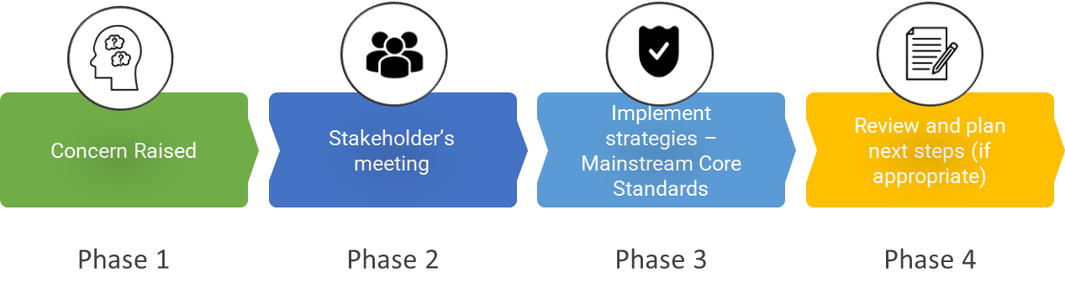

|  |  |
| --- | --- |
| **Phase 1** | If you think your child might have SEND, raise your concern with the school so that the SENCo is aware.  You can request a meeting with the class teacher and/or SENCo by calling or emailing the office (01322 665212 / [office@st-marys-swanley.kent.sch.uk](mailto:office@st-marys-swanley.kent.sch.uk) ) or by emailing the SENCo directly on [chawkins@st-marys-swanley.kent.sch.uk](mailto:chawkins@st-marys-swanley.kent.sch.uk) |
| **Phase 2** | We will meet with you to discuss your concerns and try to get a better understanding of what your child’s strengths and difficulties are. Together we will decide what outcomes to seek for your child and agree on next steps. We will make a note of what’s been discussed and add this to your child’s record. |
| **Phase 3** | We will implement the agreed strategies and monitor these over an agreed period of time. These are likely to be universal strategies set out in the mainstream core standards. A copy of this can be found here: <https://www.kelsi.org.uk/__data/assets/pdf_file/0005/117257/Special-educational-needs-mainstream-core-standards-guide-for-parents.pdf> . This will initiate the ‘Graduated Approach’ where support will be continually reviewed. See next page for more details. |
| **Phase 4** | If we decide that your child needs SEND support, we will formally notify you and your child will be added to the school’s SEND register. They will receive additional support and this will be reviewed using the assess, plan, do, review model. |

# 4. What happens if the school identifies a need?

The same process is followed if a concern is raised by the school.



All our class teachers are responsible for the monitoring of all pupils who have been identified as having SEND. They also review those who are not making the expected level of progress in their schoolwork or socially.

If the teacher notices that a pupil is having difficulties, they try to find out if the pupil has any gaps in their learning. If they can find a gap, the school will provide appropriate support. Pupils who don’t have SEND usually make progress quickly once the gap in their learning has been filled.

If the pupil is still finding it difficult to make the expected progress, the teacher will talk to the SENCo, and will contact you to discuss the possibility that your child has SEND, and the school will follow the graduated approach (see next page).

# 5. How will the school measure my child’s progress?

We will follow the ‘graduated approach’ to meeting your child’s SEND needs.

The graduated approach is a 4-part cycle of **assess, plan, do, review**.

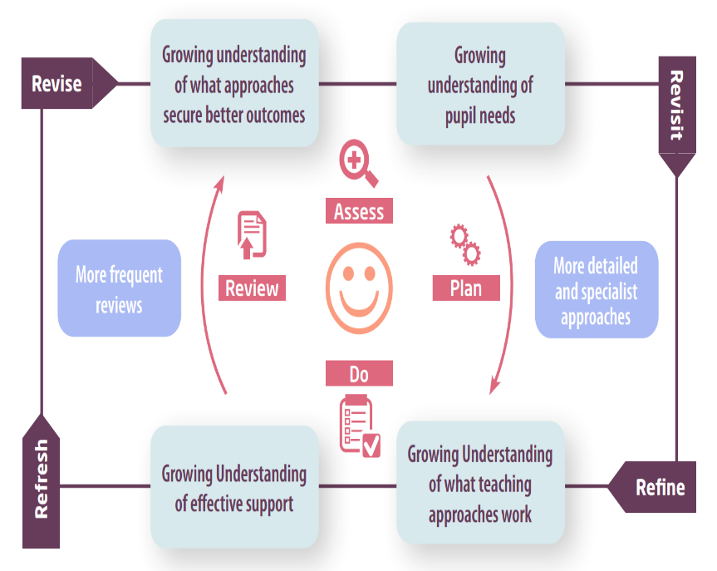

|  |  |
| --- | --- |
| **Assess** | If your child is not making the expected level of progress, we will make an assessment to find out what strengths and difficulties your child has. We will ask for you and your child’s input, as well as getting help from external professionals where necessary. |
| **Plan** | In discussion with you and your child, we will decide what outcomes we are hoping to achieve. We will make a plan of the support we will offer your child to help them meet those outcomes. We will make a record of this and share it with you and all relevant school staff. |
| **Do** | We will put our plan into practice.  The class teacher, with the support of the SENCO, will be responsible for working with your child on a daily basis, and making sure the support we put in place is having the impact we intended. |
| **Review** | We will assess how well the support we put in place helped the pupil to meet the outcomes we set. We will use our improved understanding of your child’s needs to improve the support we offer; this may mean the Plan, Assess, Do, Review cycle continues. |

# 6. How will I be involved in decisions made about my child’s education?

The class teacher will provide termly reports on your child's progress.

For children on the SEND register, the SENCo will invite you in for a meeting three times a year to:

* Set clear outcomes for your child’s progress
* Review progress towards those outcomes
* Discuss the support we will put in place to help your child make that progress
* Identify what we will do, what we will ask you to do, and what we will ask your child to do

We know that you’re the expert when it comes to your child’s needs and aspirations. So, we want to make sure you have a full understanding of how we’re trying to meet your child’s needs, so that you can provide insight into what you think would work best for your child.

We also want to hear from you as much as possible so that we can build a better picture of how the SEND support we are providing is impacting your child outside of school.

If your child’s needs or aspirations change at any time, please let us know right away so we can keep our provision as relevant as possible.

If you have concerns that arise between these meetings, please contact the class teacher or Mrs Hawkins (chawkins@st-marys-swanley.kent.sch.uk).

# 7. How will my child be involved in decisions made about their education?

The level of involvement will depend on your child’s age and individual needs. We recognise that no two pupils are the same, so we will decide on a case-by-case basis, with your input.

We may seek your child’s views by asking them to:

* Attend meetings to discuss their progress and outcomes
* Prepare a presentation, written statement, video, drawing, etc.
* Discuss their views with a member of staff who can act as a representative during the meeting
* Complete a survey



8. How will the school adapt its teaching for my child?

Your child’s teacher is responsible and accountable for the progress and development of all the pupils in their class.

High-quality teaching is our first step in responding to your child’s needs. We will make sure that your child has access to a broad and balanced curriculum in every year they are at our school.

We will adapt our approaches to how we teach to suit the way the pupil works best. There is no 'one size fits all’ approach to adapting the curriculum, we work on a case-by case basis to make sure the adaptations we make are meaningful to your child and are guided by the Mainstream Core Standards in the first instance.

These adaptations may include:

Adapting our approaches, for example, giving longer processing times, pre-teaching of key vocabulary, reading instructions aloud, etc.



* Adapting our resources and staffing



* Using recommended aids, such as laptops, coloured overlays, visual timetables, larger font, etc.



* Teaching assistants or support staff will support pupils appropriately depending on their presentation of need



* Scaffolding lesson materials

**We may also provide the following interventions:**

Better Reading Stamina, Toe by Toe, Sounds Progress, Speech and Language Link, White Rose, One Step Ahead (maths), small group catch-up support for writing and maths.

These interventions are part of our contribution to Kent County Council’s local offer.

You may wish to read our Accessibility Plan alongside this document which outlines the adjustments we make to the school environment to ensure we:

* increase the extent to which pupils with disabilities can participate in the curriculum;
* improve the physical environment of the school to enable pupils with disabilities to take better advantage of education, benefits, facilities and services provided
* improve the availability of accessible information to pupils with disabilities.

It is available at: <https://www.st-marys-swanley.kent.sch.uk/policies/>

# 9. How will the school evaluate whether the support in place is helping my child?

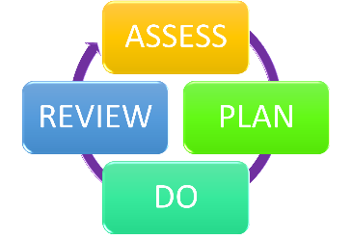We will evaluate the effectiveness of provision for your child by:

* Reviewing their progress towards their goals each term, including analysis of Target Tracker
* Reviewing the impact of interventions after 12 weeks
* Using pupil questionnaires
* Monitoring by the SENCO
* Using provision maps / intervention tracking to measure progress
* Holding an annual review (if they have an education, health and care (EHC) plan)

# 10. How will the school ensure my child has appropriate resources?

It may be that your child’s needs mean we need to provide additional resources such as:

* Additional resources to support their learning
* Adaptations to in class support
* Further training for our staff
* External specialist expertise

Where appropriate, we will consult with external agencies to get recommendations on what will best help your child access their learning and use our best endeavours to ensure these are supplied. Where additional funding is required to offer additional provision, the school will make an application to the Local Authority for High Needs Funding.

# 11. How will the school make sure my child is included in activities alongside pupils who don’t have SEND?

The expectation is that all schools providing an inclusive provision for all pupils. It may be necessary for some pupils to receive interventions in addition to a broad and balanced curriculum.

All of our extra-curricular activities and school visits are available to all our pupils, including our before and after-school clubs.

All pupils are encouraged to go on our school trips, including any residential trips

All pupils are encouraged to take part in sports day, school plays and any additional workshops.

No pupil is ever excluded from taking part in these activities because of their SEN or disability and we will make whatever reasonable adjustments are needed to make sure that they can be included.

# Munshi HR Solutions Limited - HR Service Company in Bangladesh12. How does the school make sure the admissions process is fair for pupils with SEN or a disability?

As indicated in our admission policy, our oversubscription criteria ensures that children with medical, health, social or special needs are given a level of priority in accordance with the school’s legal obligations, in particular those under the Equality Act 2010. (For further information see <https://primarysite-prod-sorted.s3.amazonaws.com/stmarys-ceva-ps/UploadedDocument/a9e7ec58-064e-4735-83e2-90c4e99f29ec/admissions-policy-2023.pdf> )

Parents of prospective pupils with a disability are encouraged to view the school and speak to the SENCo in advance of their application. Once an offer of a place has been given, a transition plan can be devised between school and home to ensure the pupil makes a successful start to their St Mary’s journey. For children with EHCPs, the Local Authority will allocate St Mary’s if they feel the provision available meets the needs of the child.

# 13. How does the school support pupils with disabilities?



You’re disabled under the Equality Act 2010 if you have a physical or mental impairment that has a ‘substantial’ and ‘long-term’ negative effect on your ability to do normal daily activities. At St Mary’s we aim to treat all our pupils fairly and with respect. This involves providing access and opportunities for all pupils without discrimination of any kind. It is our belief that no one will flourish unless we all flourish.

The accessibility plan is available online on the school website, and paper copies are available upon request. <https://www.st-marys-swanley.kent.sch.uk/policies/>

# 14. How will the school support my child’s mental health and emotional and social development?

We provide support for pupils to progress in their emotional and social development in the following ways:

* Pupils with SEND are encouraged to be part of the school council alongside pupils without SEND
* Pupils with SEND are also encouraged to be part of social skills clubs to promote teamwork/building friendships
* We provide extra pastoral support for listening to the views of pupils with SEND by offering counselling through Time2Talk or play therapy where appropriate.
* We run a nurture club for pupils who need extra support with social or emotional development
* We have a ‘zero tolerance’ approach to bullying. Please see our behaviour policy for further information. <https://www.st-marys-swanley.kent.sch.uk/policies/>
* Pupils on the SEN register complete a pupil passport annually. This outlines their view on their learning and their experience of school. It is used to tailor the provision outline in their SEN and provision plans.

# 15. What support is in place for looked-after and previously looked-after children with SEND?



Mrs Amanda McGarrigle is the designated teacher for looked-after and previously looked-after children. She works closely with our SENCO, to make sure that all teachers understand how a looked-after or previously looked-after pupil’s circumstances and their SEND might interact, and what the implications are for teaching and learning.

Pupils who are looked-after or previously looked-after will be supported much in the same way as any other child who has SEND. However, looked-after pupils will also have a personal education plan (PEP). We will make sure that the PEP and any SEND support plans or EHC plans are consistent and complement one another.

# 16. What support will be available for my child as they transition between classes or settings or in preparing for adulthood?

Between years

To help pupils with SEND be prepared for a new school year we:

* Ask both the current teacher and the next year’s teacher to attend a transition meeting when the pupils’ SEND is discussed
* Schedule a moving up day and informal sessions with the incoming teacher towards the end of the summer term
* Provide a social story to ensure children know who their key adults are

Between schools

When your child is moving on from our school, we will ask you and your child what information you want us to share with the new setting.

The SENCO of the secondary school will come into our school for a meeting with our SENCO. They will discuss the needs of all the pupils who are receiving SEND support.

Pupils might be prepared for the transition by:

* Practising with a secondary school timetable
* Learning how to get organised independently
* Plugging any gaps in knowledge

# 17. What support is available for me and my family?

If you have questions about SEND, or are struggling to cope, please get in touch to let us know. We want to support you, your child and your family.

To see what support is available to you locally, have a look at Kent’s local offer. <https://www.kelsi.org.uk/special-education-needs/special-educational-needs>

Our local special educational needs and disabilities information advice and support services (SENDIASS) organisations is: Information Advice and Support Kent (IASK)

They can be contacted on

HELPLINE: 03000 41 3000

Office: 03000 412412

E-mail: iask@kent.gov.uk

Local charities that offer information and support to families of pupils with SEND are:

* [Autism and ADHD parent support UK](https://aaps-uk.org/)
* [Advocacy for All](https://www.advocacyforall.org.uk/)
* [Homestart](https://homestartnwkent.org.uk/)
* [We Are Beams](https://wearebeams.org.uk/)

National charities that offer information and support to families of pupils with SEND are:

* [IPSEA](https://www.ipsea.org.uk/)
* [SEND family support](https://sendfs.co.uk/)
* [NSPCC](https://www.nspcc.org.uk/keeping-children-safe/support-for-parents/supporting-children-special-educational-needs-disabilities/)
* [Family Action](https://www.family-action.org.uk/what-we-do/children-families/send/)
* [Special Needs Jungle](https://www.specialneedsjungle.com/)

# 18. What should I do if I have a complaint about my child’s SEND support?

The normal arrangements for the treatment of complaints at St Mary’s are used for complaints about provision made for special educational needs. We encourage parents to discuss their concerns with the class teacher, SENCO or Headteacher to resolve the issue before making the complaint formal to the Chair of the Governing Body.

If the complaint is not resolved after it has been considered by the governing body, then a disagreement resolution service or mediation service can be contracted. If it remains unresolved after this, the complainant can appeal to the First–tier Tribunal (Special Educational Needs and Disability), if the case refers to disability discrimination, or to the Secretary of State for all other cases.

There are some circumstances, usually for children who have an Education, Health Care Plan, where there is a statutory right for parents to appeal against a decision of the Local Authority. Complaints which fall within this category cannot be investigated by the school.

Complaints about SEND provision in our school should be made to the headteacher in the first instance. They will then be referred to the school’s complaints policy.

If you are not satisfied with the school’s response, you can escalate the complaint. In some circumstances, this right also applies to the pupil themselves.

To see a full explanation of suitable avenues for complaint, see pages 246 and 247 of the [SEND Code of Practice](https://www.gov.uk/government/publications/send-code-of-practice-0-to-25).

If you feel that our school discriminated against your child because of their SEND, you have the right to make a discrimination claim to the first-tier SEND tribunal. To find out how to make such a claim, you should visit: <https://www.gov.uk/complain-about-school/disability-discrimination>

You can make a claim about alleged discrimination regarding:

* Admission
* Exclusion
* Provision of education and associated services
* Making reasonable adjustments, including the provision of auxiliary aids and services

Before going to a SEND tribunal, you can go through processes called disagreement resolution or mediation, where you try to resolve your disagreement before it reaches the tribunal.

<https://www.kent.gov.uk/education-and-children/special-educational-needs/education-health-and-care-plans/if-your-child-does-not-get-a-needs-assessment-or-ehc-plan>

# 19. Supporting documents

* *Equality Information and Objectives Policy*
* *Child protection and safeguarding policy*
* *Behaviour Policy*
* *Accessibility Plan*
* *Attendance and punctuality policy*
* *SEND policy*
* *SEN & Disabilities Code Of Practice 2015*
* *Mainstream Core Standards*

# 20. Glossary

* **Access arrangements** – special arrangements to allow pupils with SEND to access assessments or exams
* **Annual review** –an annual meeting to review the provision in a pupil’s EHC plan
* **Area of need** – the 4 areas of need describe different types of needs a pupil with SEND can have. The 4 areas are communication and interaction; cognition and learning; physical and/or sensory; and social, emotional and mental health needs.
* **CAMHS** – child and adolescent mental health services
* **Differentiation** – when teachers adapt how they teach in response to a pupil’s needs
* **EHC needs assessment** – the needs assessment is the first step on the way to securing an EHC plan. The local authority will do an assessment to decide whether a child needs an EHC plan.
* **EHC plan** –an education, health and care plan is a legally-binding document that sets out a child’s needs and the provision that will be put in place to meet their needs.
* **First-tier tribunal/SEND tribunal** – a court where you can appeal against the local authority’s decisions about EHC needs assessments or plans and against discrimination by a school or local authority due to SEND
* **Graduated approach** – an approach to providing SEND support in which the school provides support in successive cycles of assessing the pupil’s needs, planning the provision, implementing the plan, and reviewing the impact of the action on the pupil
* **Intervention** – a short-term, targeted approach to teaching a pupil with a specific outcome in mind
* **Local offer** – information provided by the local authority which explains what services and support are on offer for pupils with SEND in the local area
* **Outcome** – target for improvement for pupils with SEND. These targets don't necessarily have to be related to academic attainment
* **Reasonable adjustments** – changes that the school must make to remove or reduce any disadvantages caused by a child’s disability
* **SENCO** – the special educational needs co-ordinator
* **SEN** – special educational needs
* **SEND** – special educational needs and disabilities
* **SEND Code of Practice** – the statutory guidance that schools must follow to support pupils with SEND
* **SEND information report** – a report that schools must publish on their website, that explains how the school supports pupils with SEND
* **SEND support** – special educational provision which meets the needs of pupils with SEND
* **Transition** – when a pupil moves between years, phases, schools or institutions or life stages