**Year 1 Long Term Plan**

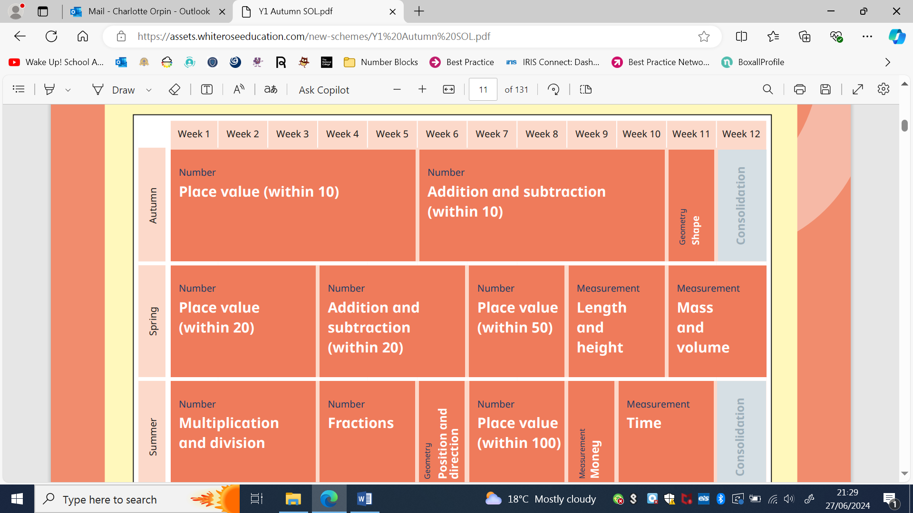

**Mental Maths Long Term Plan**

Year 1

|  |  |  |  |  |  |  |
| --- | --- | --- | --- | --- | --- | --- |
| **Term** | **One** | **Two** | **Three** | **Four** | **Five** | **Six** |
| Counting | Counting to 20. | Counting to 20. | Counting to 50. | Counting to 50. | Counting to 100. | Counting to 100. |
| Flashcards | Numbers 0-20. | Numbers 0-20.  2D and 3D shapes. | Numbers 20-50.  2D and 3D shapes. | Numbers 20-50.  2D and 3D shapes. | Fractions. | Coins and notes. |
| Number/ Place Value | Addition and subtraction within 10.  1 more 1 less.  Ordering. | Addition and subtraction within 10.  1 more 1 less.  Ordering. | Comparing numbers to 20.  1 more 1 less.  Ordering. | Addition and subtraction within 50.  1 more 1 less.  Ordering.  Partitioning. | Sharing.  Arrays. | Comparing numbers to 100.  1 more 1 less.  Ordering.  Partitioning. |
| Songs/Rhymes | Number bonds to 10. | Number bonds to 10 and 20. | Number bonds to 10 and 20. | Number bonds to 10 and 20. | Counting in 2s, 5s and 10s. Counting to 100. | Counting in 2s, 5s and 10s. Counting to 100. |