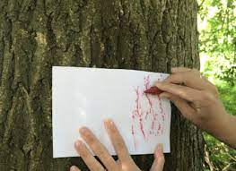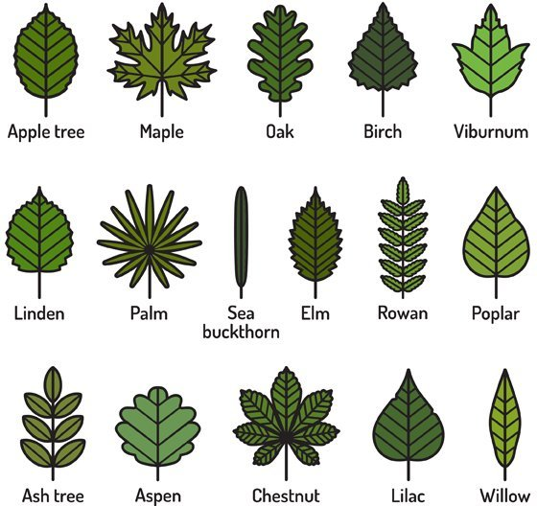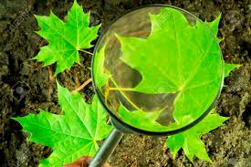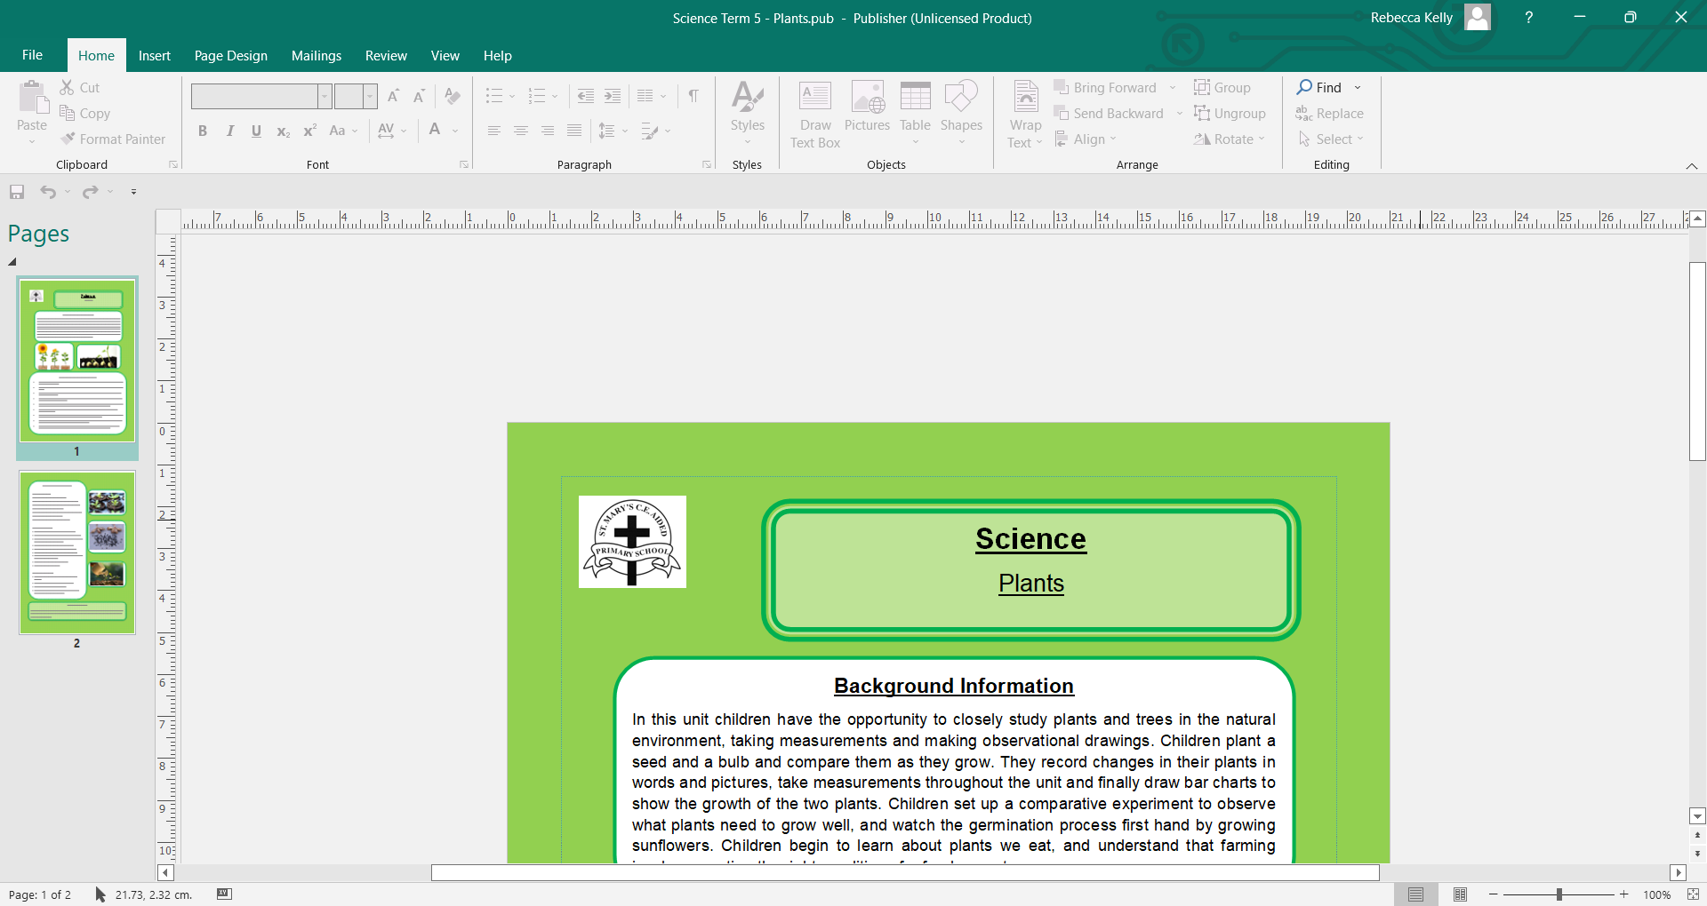

In this unit, the children will:

* Look closely at trees, drawing and labeling their parts.
* Make a bark rubbing from a tree.
* Go on a scavenger hunt for different trees around the school grounds, naming them.
* Identify and categorise trees into deciduous and evergreen.
* Name the months of the year and the seasons linked to them.
* Explore how the season of Summer affects the weather.
* Discover how the number of daylight hours changes throughout the year.
* Create a sun safe poster.

**Background Information**

This term, the children will continue to explore the theme of plants using trees in our local school environment. They will name the parts of a tree and the children will make bark rubbings from them. They will learn to look closely at the trees, identifying them using their leaves and finding out about the differences between deciduous and evergreen trees.

The children will also explore seasonal change. They will learn how the season of Summer affects the world around us, including finding out about plants, animals and the weather. They will discover how the day length varies throughout the year, depending on the season. The children will also find out about how to stay safe in the sun, including the use of sun cream, sun hats and appropriate clothing.

Science – Plants and Seasonal Change

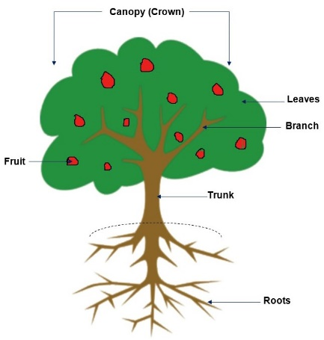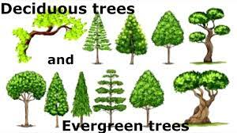

**By the end of this unit…**

All children can:

* Make a bark rubbing.
* Look closely at a leaf using equipment.
* Name the parts of the tree.
* State which season we are in and what the weather is like.
* Create a simple sun safety poster.

Most children will:

* Draw a tree and label its parts.
* Identify some trees using their leaves.
* State if a tree is evergreen or deciduous.
* Name and order the months of the year, linking them to the seasons.
* Describe what happens to the weather and the natural world in Summer.
* Notice how the daylength changes throughout the year.
* Explain how to stay safe in the sun.

Some children will:

* Identify a wide range of trees.
* Explain the key differences between deciduous and evergreen trees and how to identify them.
* Explain how day length varies.

**Key Vocabulary:**

Plants, trees, root, leaves, trunk, branches, twigs, sticks, bark, fruit, seeds, nuts, berries, animals, wind, spread, seedling, grow, lifecycle, deciduous, evergreen, narrow, broad, spiky, smooth, bumpy, veins.

Summer, Autumn, Winter, Spring, change, sun, hot, sun cream, sun hat, water, sun glasses, day length, longer, shorter, hours, weather, months of the year.