

Welcome to Year 1!

For homework in Year 1 you will get a weekly Phonics homework. This will consist of 3 or 4 Phonics sounds that we have been learning in class that week, with some words for you to practise reading the sounds in. Sometimes you will also get an alien word activity sheet to help you prepare you for the Phonics Screening Check in June.

Each term we will get 1 creative task to complete over the holidays because we know how much you enjoy these fun activities!

These brightly coloured folders we have given you are your homework folders. They need to last all year so make sure you take care of them! On a Friday we will take all of the completed homework out of the folder and put your new homework in there.

On a Friday we will also send you your weekly spellings to practice.

Every week we would still like you to:

1. Read at least **3 times each week** to get a prize from the box. This is very important to help us become more independent learners.
2. Play the 1-minute games on the White-Rose Maths App.
3. Practise your spellings at home.

[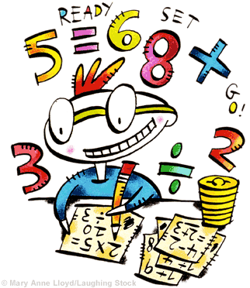](https://www.google.co.uk/url?sa=i&url=http://clipart-library.com/numeracy-clipart.html&psig=AOvVaw06c5MX054jdwHzMbJ4HbVQ&ust=1605126377168000&source=images&cd=vfe&ved=0CAIQjRxqFwoTCPCnvO_n-OwCFQAAAAAdAAAAABAD)

Any questions please just come and ask.

Thank you,

Miss Bailey ☺