Year 2 Long Term Plan
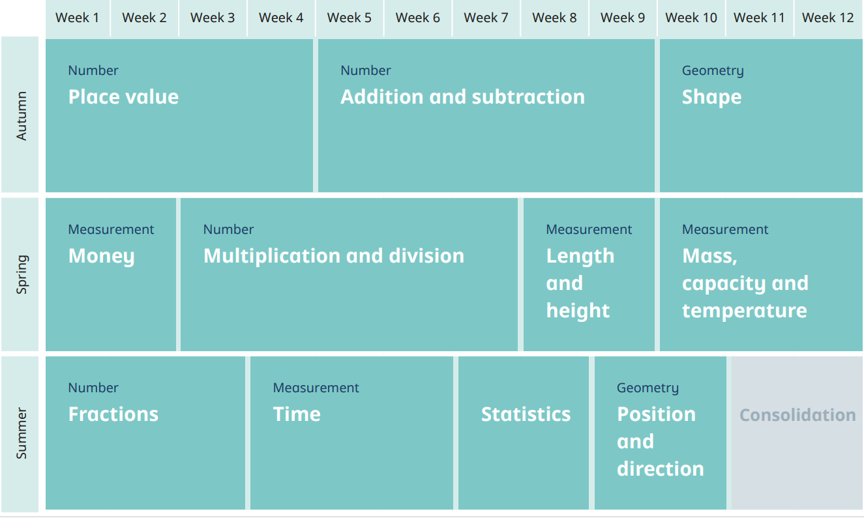
Mental Maths Long Term Plan
Year 2
Term | One | Two | Three | Four | Five | Six
Counting | Counting to 100.  Counting in 2s, 5s and 10s. | Counting to 100.  Counting in 2s, 5s and 10s. | Counting to 100.  Counting in 2s, 5s, 10s and 3s. | Counting to 100.  Counting in 2s, 5s, 10s and 3s. | Counting to 100.  Counting in 2s, 5s, 10s and 3s. | Counting to 100.  Counting in 2s, 5s, 10s and 3s.
Flashcards | 2D and 3D shapes. | 2D and 3D shapes. | Coins and notes. | Coins and notes. | Fractions. | Fractions.
Number/ Place Value | Partitioning.  Complex partitioning.  Ordering numbers.  Comparing numbers. | Partitioning.  Complex partitioning.  Ordering numbers.  Comparing numbers. | Making amounts of money in different ways.  Fact families. | Making amounts of money in different ways.  Fact families. | Fractions of amounts.  Addition.  Subtraction.  Multiplication.  Division. | Fractions of amounts.  Addition.  Subtraction.  Multiplication.  Division.
Songs/Rhymes | Number bonds to 10 and 20. | Number bonds to 10, 20 and 100. | Number bonds to 10, 20 and 100.  2, 5, 10, 3 x tables. | Number bonds to 10, 20 and 100.  2, 5, 10, 3 x tables. | Number bonds to 10, 20 and 100.  2, 5, 10, 3 x tables. | Number bonds to 10, 20 and 100.  2, 5, 10, 3 x tables.

