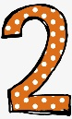
Happy Friday Year 2!
This term you have got an extra creative homework; this one has been set for the whole school by Mrs Shelton. Your homework will be due back at school by Friday 28th March 2025.

Mrs Shelton would like you to make your own Easter Bonnet! This can look like whatever you want and can be as creative as you like. On the last day of term we will be wearing our hats at an Easter Bonnet parade as part of our Easter end of term celebrations. Here are some ideas for your bonnets:
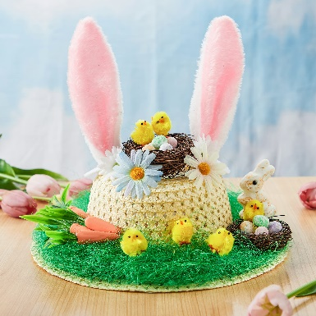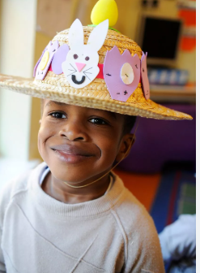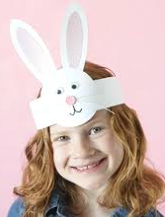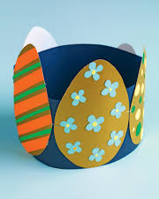

Whilst you complete your Creative homework we would still like you to:
- Read at least 3 times each week. If you read 5 times a week you will get a prize from the box. This is very important to help us become more independent learners.
- Play the 1-minute games on the White-Rose Maths App.
- Practise your spellings at home.
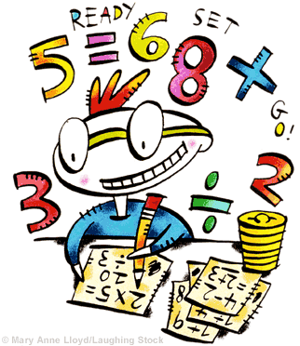
Any questions please just come and ask.
Miss Orpin

