
Happy Friday Year 2!
Well done for completing another term at St Mary’s.
Your homework for the next few weeks is a creative homework. It is due in by Friday 25th April 2025.
In RE this term we have been learning about the Easter Story and talking about why it is so important for Christians. For your homework this term we would like you to create an Easter garden. Here are some examples:
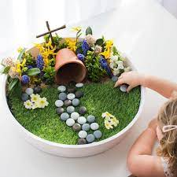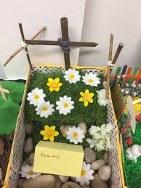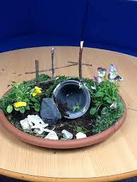
Be as creative as you like! It can be as big or as small as you like but it must include something that reminds you of the Easter Story. Any pieces of homework that impress us will get a prize from the box.

Whilst you complete your Creative homework we would still like you to:
- Read at least 3 times each week. If you read 5 times a week you will get a prize from the box. This is very important to help us become more independent learners.
- Play the 1-minute games on the White-Rose Maths App.
- Practise your spellings at home- Recap all of your spellings so far from this term. Can you still remember them all?

Any questions please just come and ask.
Thank you,
Miss Orpin

