
Happy Friday Year 2!
Well done for completing another term at St Mary’s.
As we are coming to the end of the term your homework for the next few weeks will be a Creative one! Your homework will be due back at school by Friday 14th February 2025.
Your Creative homework this term will be linked to our Geography topic of Kenya! I would like you to create your favourite Big Five animal that we have been learning about. The Big Five animals are: the African elephant, the African Lion, the Cape Buffalo, the White or Black Rhino and the Leopard.
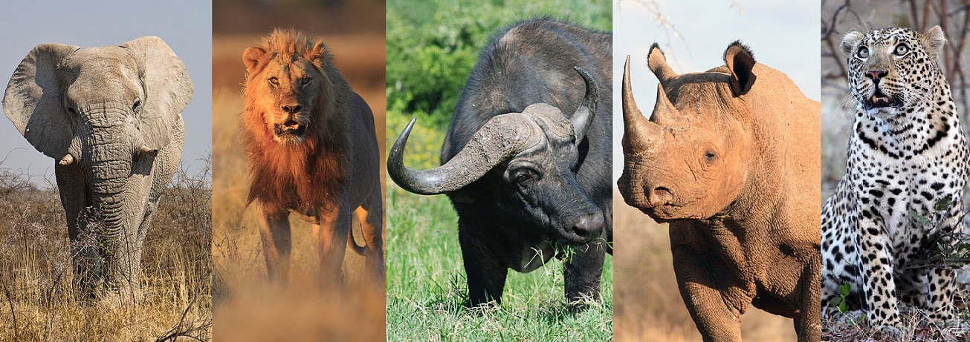
Please make your work as creative as possible! You could use paintings, collages, Lego, Playmobile or junk modelling! Any pieces of homework that impress us will get a special certificate and a prize from the box!

Whilst you complete your Creative homework we would still like you to:
- Read at least 3 times each week. If you read 5 times a week you will get a prize from the box. This is very important to help us become more independent learners.
- Play the 1-minute games on the White-Rose Maths App.
- Practise your spellings at home- Recap all of your spellings so far from this term. Can you still remember them all?
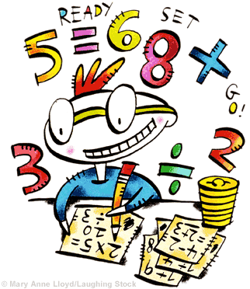
Any questions please just come and ask.
Miss Orpin

