
Happy Friday Year 2!
Well done for completing another term at St Mary’s. You all did a fantastic job during our Christmas Nativity and all of the teachers are very proud of you!
As we are coming to the end of the term your homework for the next few weeks will be a Creative one! Your homework will be due back at school by Friday 10th January 2025.
Your Creative homework this term will be linked to our topic of Christmas! I would like you to create your favourite part of the Christian Christmas story. If you can’t remember the story scan this QR Code to watch it again:
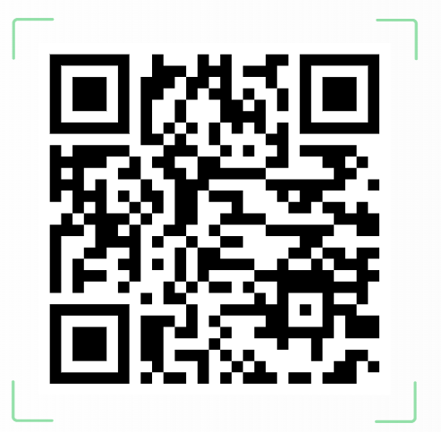
Please make your work as creative as possible! You could use paintings, collages, Lego, Playmobile or junk modelling! Any pieces of homework that impress us will get a special certificate and a prize from the box!

Whilst you complete your Creative homework we would still like you to:
- Read at least 3 times each week. If you read 5 times a week you will get a prize from the box. This is very important to help us become more independent learners.
- Play the 1-minute games on the White-Rose Maths App.
- Practise your spellings at home- Recap all of your spellings so far from this term. Can you still remember them all?
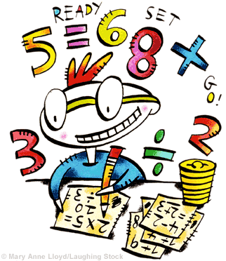
Any questions please just come and ask.
Miss Orpin

