
Happy Friday Year 2!
Well done for almost completing our first (very long) term back at school! You have all worked so hard and we are very proud of you!

As we have come to the end of the term your homework for the next 2 weeks will be a Creative one! Your homework will be due back at school by Friday 8th November.

Your Creative homework this term will be linked to our PSHE topic of ‘Being Me in My World’. I would like you to create a poster that shows off what makes you special and unique! What makes you the amazing person that you are? Is it your family? Your skills? Your personality?
Please make your posters as creative as possible! You could use paintings, drawings or photographs! Any pieces of homework that impress us will get a special certificate and a prize from the box!

Whilst you complete your Creative homework we would still like you to:
- Read at least 3 times each week. If you read 5 times a week you will get a prize from the box. This is very important to help us become more independent learners.
- Play the 1-minute games on the White-Rose Maths App.
- Practise your spellings at home- Recap all of your spellings so far from this term. Can you still remember them all?

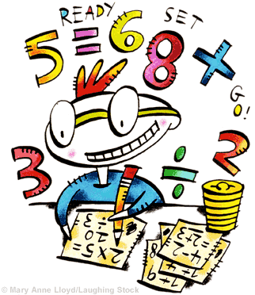
Any questions please just come and ask.
Thank you,
Miss Orpin

