
Welcome to Year 2!
In Year 2 you will get a daily 5-10 minutes Phonics activity sheet. On a Wednesday you will get either a Maths or Writing activity sheet instead.
Each term we will still give you a creative task because we know how much you enjoy these fun activities!
These brightly coloured folders we have given you are your homework folders. They need to last all year so make sure you take care of them! Each day the folders will need to come back to school so we can give you your new sheet. On a Friday we will take all of the completed homework out of the folder.
On a Friday we will still send you your weekly spellings to practice.

Every week we would still like you to:
- Read at least 3 times each week to get a prize from the box. This is very important to help us become more independent learners.
- Play the 1-minute games on the White-Rose Maths App.
- Practise your spellings at home.

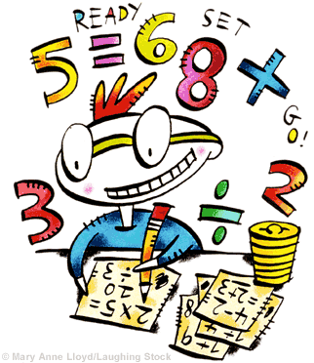
Any questions please just come and ask.
Thank you,
Miss Orpin

