Dear parents/carers,
This term Year 2 are taking part in our school allotment competition focusing on sustainability and recycling. We have decided to create a garden plot to encourage bees and butterflies but we need your help! We are going to be planting wildflower seeds and growing our own sunflowers. Plus, we are going to be making different bug hotels and a bee and butterfly water bath:
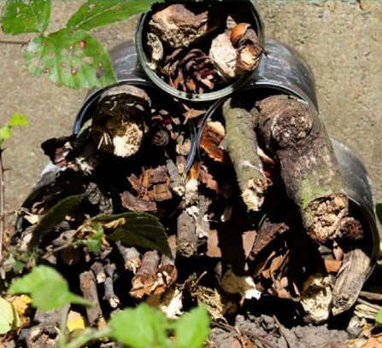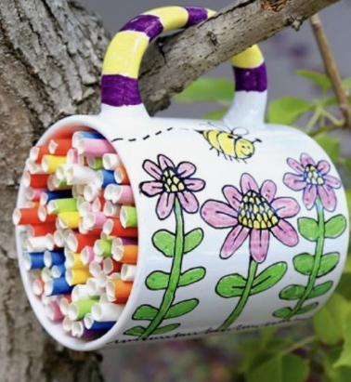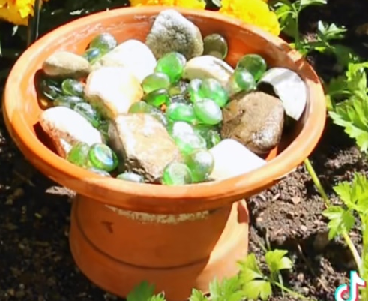
We are looking for any of the following resources:
- Old mugs
- Straws
- Stones
- Coloured gems/marbles
- Bark
If you have any of these items hanging around at home that you no longer need we would love to make use of them in our garden plot!
Please can we have any donations asap.
Keep an eye on our class website page to see the progress we make each week. We can’t wait to share our finished plot with you!
Any questions please come and ask!
Miss Orpin

