**A Day In The Life of Carle Class**

When we first arrive and go into nursery, we hang up our coats, put our bags in the box, and self-register. We do this by reading our names and putting them under our faces. We also do our handwriting, where we practice our pencil grip, writing letters and our name. Then, if we are hungry, we can have toast or bagel with butter and jam, cereal, juice and water. Then we can play with the activities that have been set up until its carpet time.

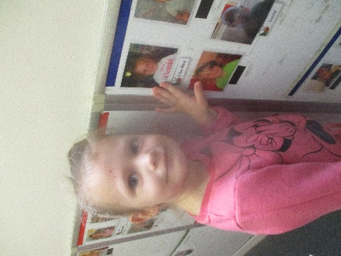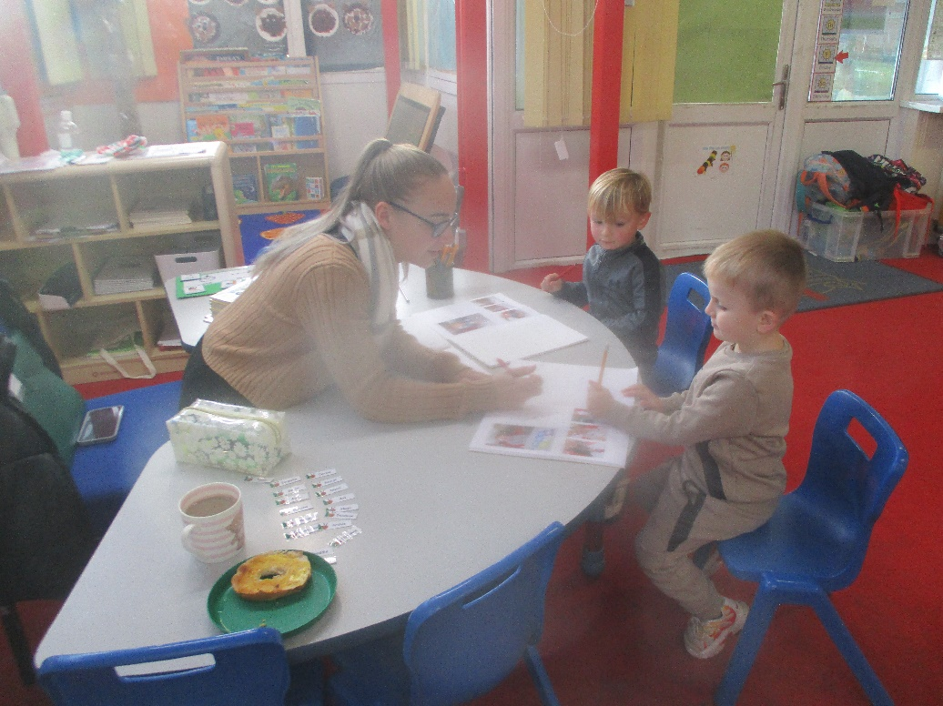

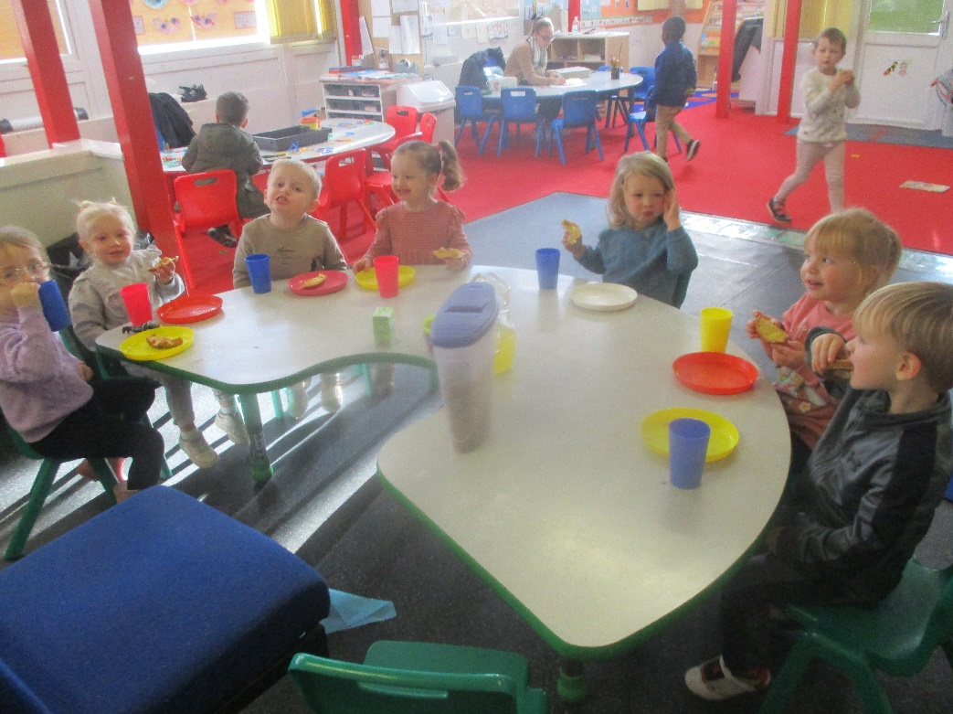

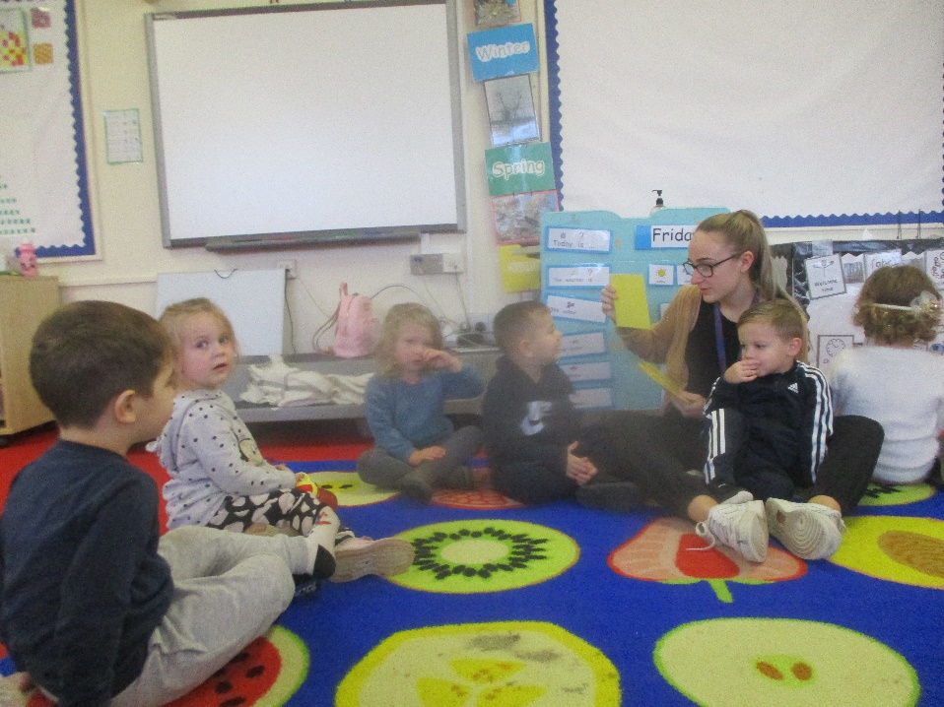At carpet time, we talk about the days of the week and the weather. Every week, we learn a new sound, number, shape and colour.

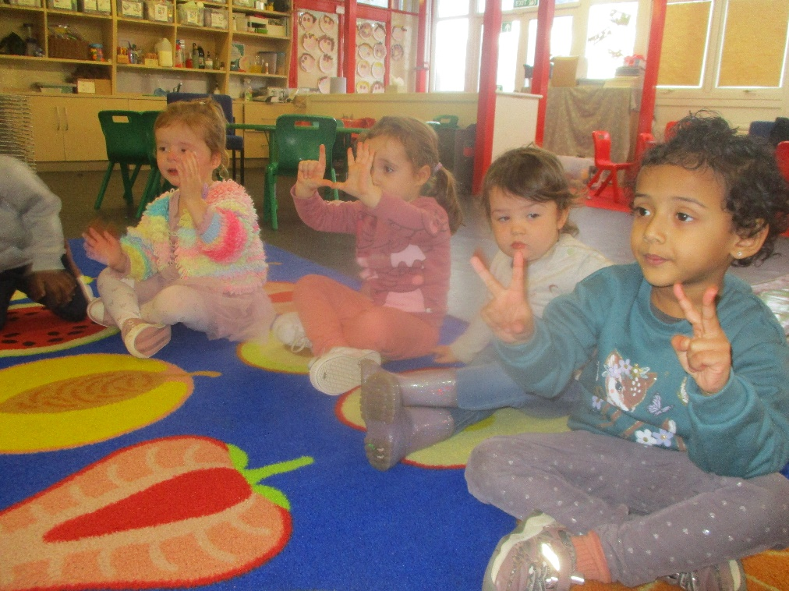

On Monday and Tuesday, in our small groups we play phonics games by practicing our initial sounds. Wednesday we learn French, and Thursday and Friday we have maths challenges to complete.

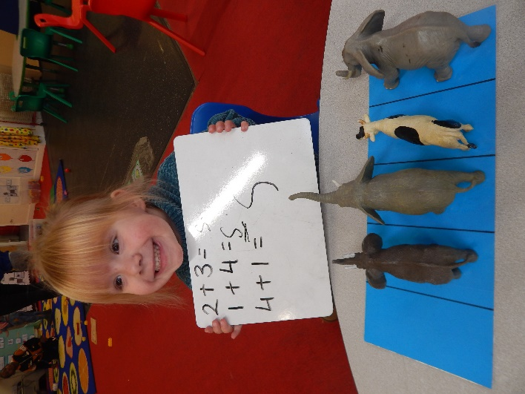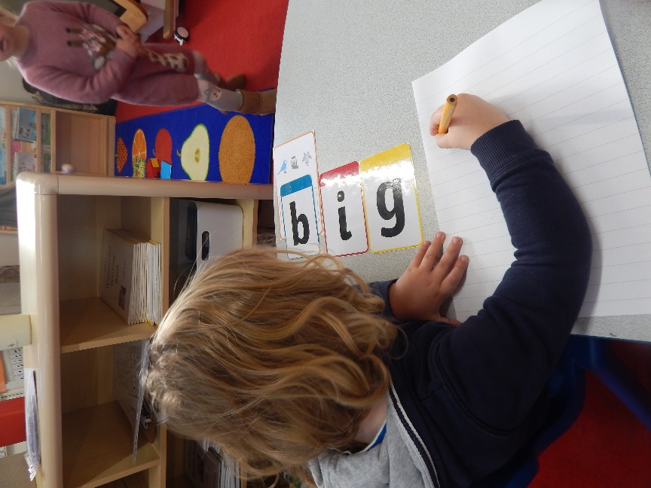

We then go for a 15-minute walk, either around the playground or on the field if it is dry. This helps us get fit as we exercise every day. We are allowed to run if we want to, and some of us can run really fast!

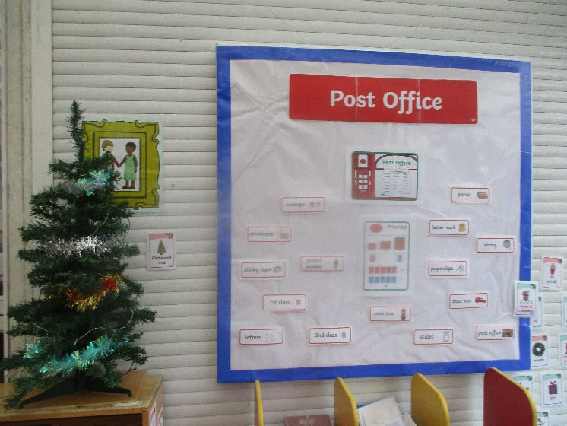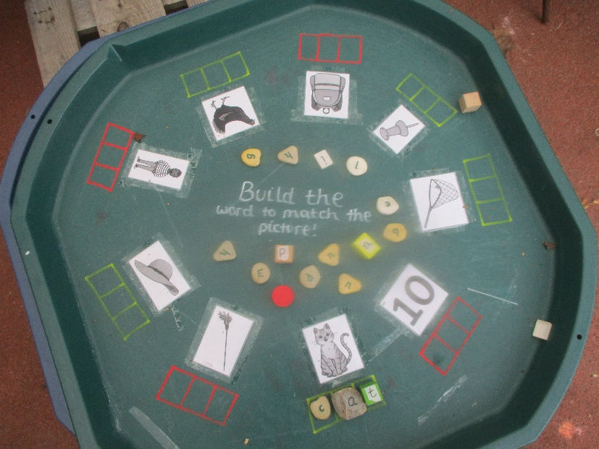We can spend time inside Nursery or Reception or outside in our wonderful garden. We can ride bikes; climb and balance; plant flowers and vegetables and then we can pick them and eat them once they have grown. We have a sand pit, a mud kitchen and a playhouse, as well as lots of toys and challenges.

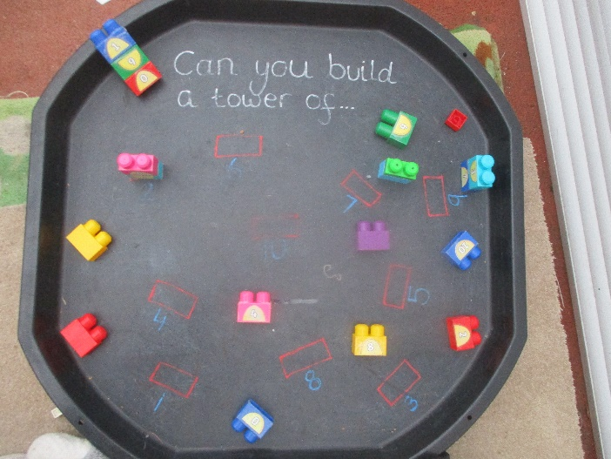



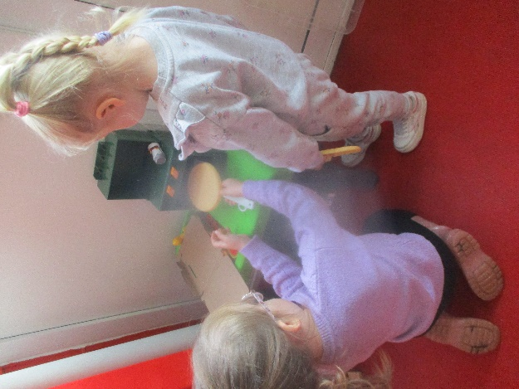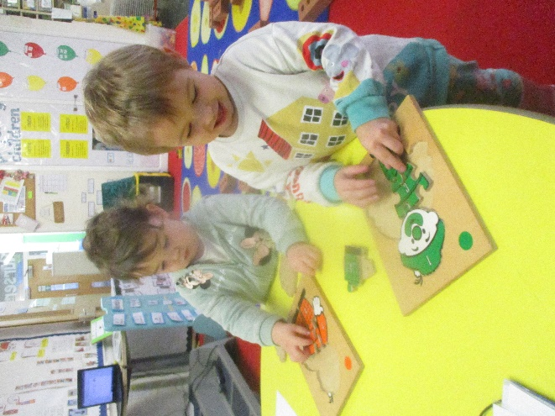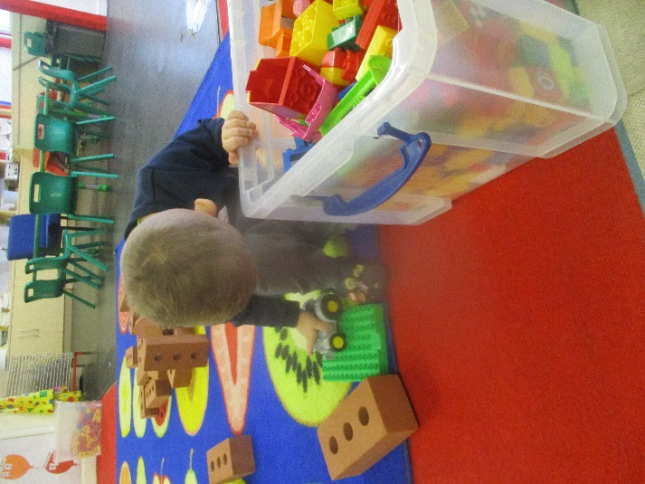When we are inside the classroom we have lots of activities and resources, which we can choose independently. We learn through our play, stories and games. We work with our adults in small groups when we are writing, counting and learning our sounds and numbers. We can play with playdough, try different types of painting, play with the sand or water, explore the interactive table or play with any of the toys.

Once we have tidied up, we have story time or sing songs. After, we wash our hands and get ready for snack time. We have different types of fruit to choose from, and have this with a drink of milk or water. We discuss what activities we have done with our adults, learning to take turns and being polite when we eat.



At home time, our parents or whomever is collecting us come into Nursery to collect us. We leave and are already excited for our next day in nursery!