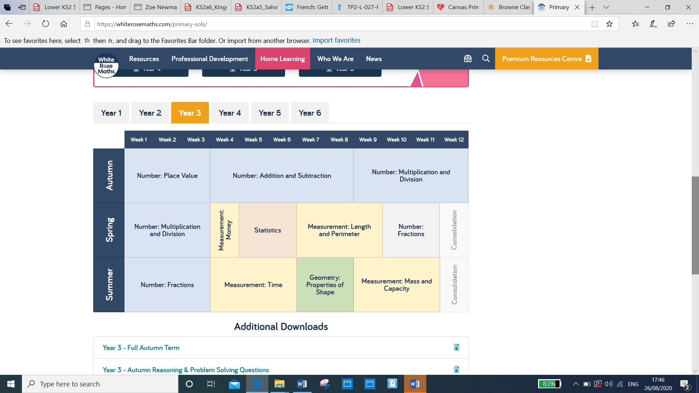Year 3 WhiteRose Maths Yearly overview